**Opatch Apply & Rollback in WebLogic**

**Opatch Upgrade with applying PSU (patch set update) patch:**

1. Take Oracle_Home Backup

**Command**: tar -cvf Oracle_Home_bkp.tar Oracle_Home

1. Stop all Running process.
2. Unzip the Downloaded Opatch file.
3. Command to Upgrade opatch.

**Command:** java -jar <Patch_Home>/6880880/opatch_generic.jar -silent oracle_home=<oracle_home_location>

1. If applying any patch, unzip and go to patch folder then run below command before applying to check results.

**Command:** opatch apply -report

1. If results with no error, go on applying patch by going inside patch folder.

**Command:** opatch apply

1. To check applied patches.

**Command:** opatch lsinventory

1. To check latest patch applied.

**Command:** opatch lspatches

1. You also check applied patches in Console.

**Path:** servers->Adminserver->Monitoring->general->below see path list

**Roll Back the applied Patch:**

1. Stop the Running Process.
2. Run below command:

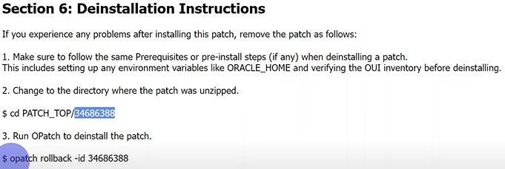



1. **Other way to Roll Back:**

* Restore the backup Directory (Oracle_Home)

**Applying SPB (stack patch bundle) Patch:**

* Note: In Case any Issue Restoring from backup is only way to Roll back Patches.

1. Create Complete Backup of ORACLE_HOME, DOMAIN_HOME & CENTRAL_INVENTORY
2. Check Opatch Version
3. Stop all Running Process.
4. Unzip the patch file and go to below paths

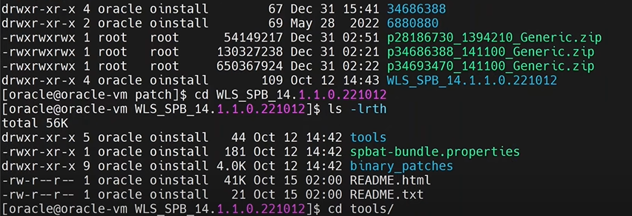

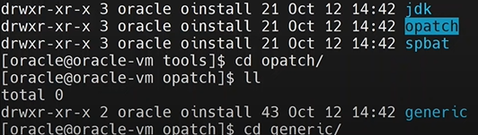

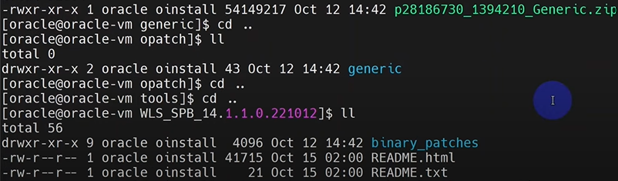

Go to Binary_patches

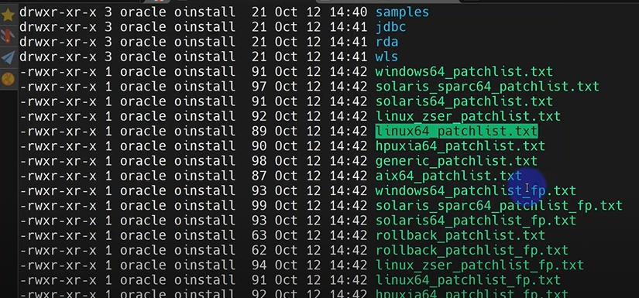

Select based on our OS.

1. Run below command to apply patch.



**Example:** -report to check results before applying patch.



After successful results run command without -report.



1. Start the services and check the applied patches.

**To Roll Back Applied Patches:**

* **Only way restore Back up.**

